4) ( Modal Analysis) Total Deformation

**Subject:**

**Author:**

**Prepared For:**

**Date**

**Comments:**

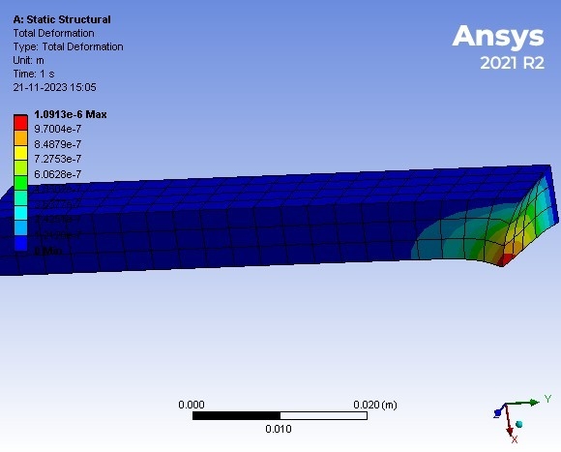

3) (Temperature analysis) Total Heat Flux

**Subject:**

**Author:**

**Prepared For:**

**Date**

**Comments:**

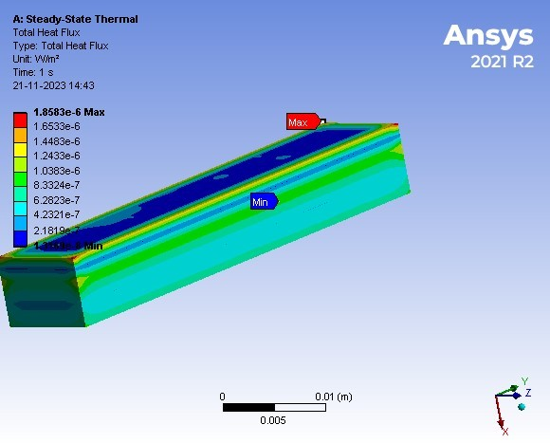

3) (Temperature analysis) Directional Heat Flux

**Subject:**

**Author:**

**Prepared For:**

**Date**

**Comments:**

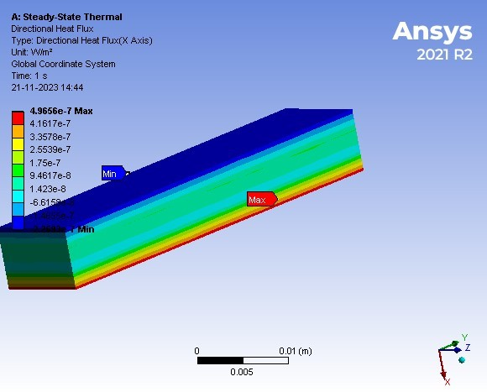

2) (1-D Beam) Maximum Principal Elastic Strain

**Subject:**

**Author:**

**Prepared For:**

**Date**

**Comments:**

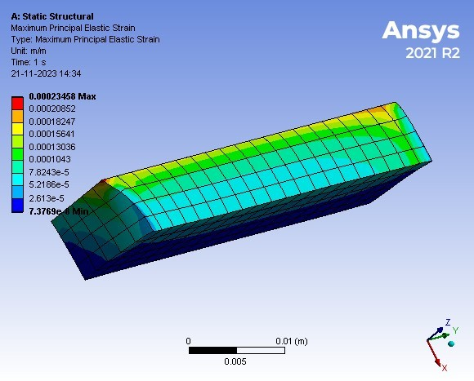

2) (1-D Beam) Total Deformation

**Subject:**

**Author:**

**Prepared For:**

**Date**

**Comments:**

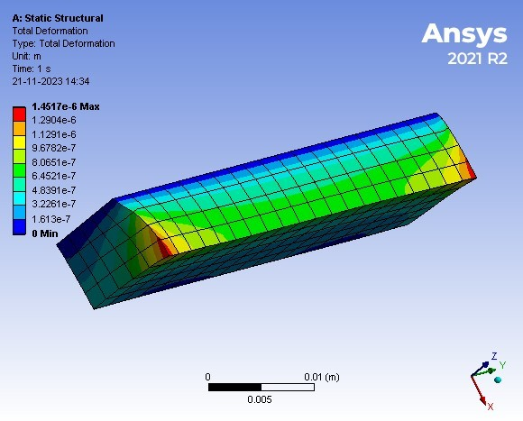

2) (1-D Beam) Maximum Principal Stress

**Subject:**

**Author:**

**Prepared For:**

**Date**

**Comments:**

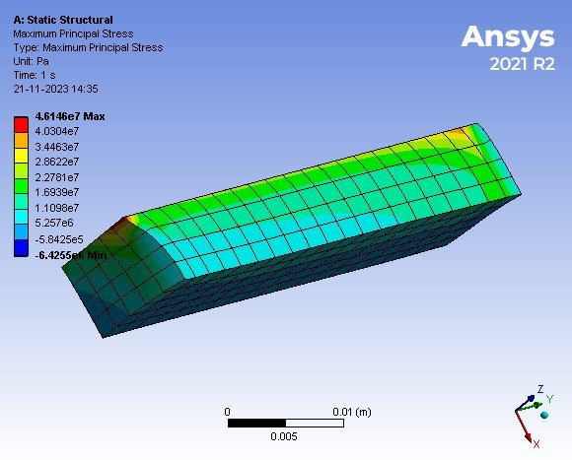

5) (Stress con) Maximum Principal Stress

**Subject:**

**Author:**

**Prepared For:**

**Date**

**Comments:**

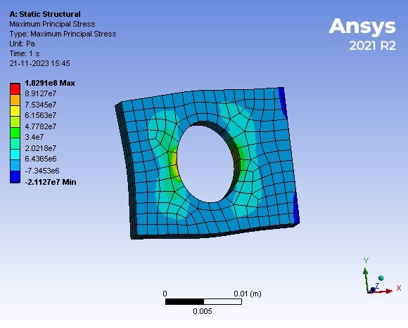

5) (Stress conc) Maximum Principal Elastic Strain

**Subject:**

**Author:**

**Prepared For:**

**Date**

**Comments:**

